Use Case Model Survey
FOR
Volunteer Management System
(VMS)

CLIENT
PROJECT | Volunteer Management System (VMS)
TITLE | Use Case Model Survey
VERSION | 1.00.1a
DATE | 10-Jul-2011
 | ORIGINATOR
 | Name / Signature | Team 8S
 | APPROVAL
 | Name / Signature | Phung Kim Cuong, Dio
Institute of Systems Science |  | Document Reference
25 Heng Mui Keng Terrace  Singapore 119615 |  | VMS/PM-1.3.1/1

 | Acceptance
 | Customer Signature |  | Customer Signature
 | Name & Designation |  | Name & Designation
 | Date & Company Stamp |  | Date & Company Stamp

Revision History

Date | Version | Description | Author
10-Jul-2011 | 1.0 | Creation | Team 8S
 |  | Refer to amendment history

Table of Contents

1. Introduction 3
2. Survey Description 3
3. Actors 3
3.1 User 3
3.2 Anonymous User 3
3.3 Volunteer 3
3.4 Staff 3
3.5 Administrator 3
3.6 Coordinator 3
3.7 Project Manager 4
4. Use Case 4
4.1 Login / Logout 4
4.2 Change Password 4
4.3 Retrieve Forgotten Password 4
4.4 Register User Account 4
4.5 Update Profile 4
4.6 Browse Project 4
4.7 Browse Member of the Project 4
4.8 Propose Project 4
4.9 Raise Project Interest 5
4.10 Post Project Experience 5
4.11 Post General Feedback 5
4.12 Request for Certificate 5
4.13 Manage Project Details 5
4.14 Assign Role to Project Member 5
4.15 Review Feedback 5
4.16 Review Project Interest 5
4.17 Send Project Invitation 5
4.18 Manage Calendar 5
4.19 Submit Project Itinerary 6
4.20 Manage Project Itinerary 6
4.21 Review Project Itinerary 6
4.22 Review Project Proposal 6
4.23 Generate Project Report 6
4.24 Manage Staff / Volunteer Account 6
4.25 Generate Certificate 6
4.26 Configure System Parameter 6
5. Overall User Case Model Survey 7
ANNEX D Amendment History 8

Introduction
The purpose this document is to provide a brief description of the project and to describe known actors and their interaction with the system. This document presents a high level view. The main requirements for the system are defined in “User Requirements Specification for Volunteer Management System”, reference VMS/T-1.2/1. The system is to be developed using object-oriented techniques and the Java programming language. For more detailed information, the reader will need to see the individual use case reports.

Survey Description
The scope of this document is to describe the functions that can be performed in the volunteer management system.

Actors

User
This actor represents the general user of the System. The user role can perform login/logout and basic profile update such as Change Password or update details.

Anonymous User
This actor represents public user who have not yet registered as a user of VMS. The Anonymous User can register as a User, or browse the list of projects in the System.

Volunteer
This actor represents a volunteer who is registered and to participate in doing volunteer work at project sites. He can be a project member or project leader for a project site. He will be able to browse for projects and raise interest on projects that he is interested in. He will also be able to post personal experience and feedback regarding a project. He also can request for certification of volunteer work and manage his own profile. Anyone outside the organization can register himself as a volunteer in order to participate in the project site.

Staff
This actor represents organization staffs who work for the volunteer organisation. A staff will be able to perform tasks that a normal user can do. A staff profile will just have different user information compare to volunteer profile.

Administrator
This actor represents a system administrator who manages the user accounts within the system, generate certificates and update system parameters.

Coordinator
This actor represents a project coordinator that participates in reviewing of itinerary and project. Project coordinator also can generate the project report to see the status of certain project.

Project Manager
This actor represents a project manager that is in charge of managing the project sites that has been assigned. He can perform manage the itinerary and calendar for each assigned project site. He also reviews feedback and project interest that has been submitted by volunteers. In addition, PM also performs assignment of volunteers to appropriate projects, submitting project itinerary for reviews or request certificates for the volunteers.

Use Case

Login / Logout
This use case allows the user to login and logout of the system when he wishes to use the system or to exit the system.

Change Password
This use case allows all the users of the system to change their password.

Retrieve Forgotten Password
This use case allows all users of the system to retrieve the password in the event that they have forgotten their password. The password will be email to their registered email.

Register User Account
This use case allows anyone who is interested to become a volunteer to register an account in the system.

Update Profile
This use case allows all the users who have a registered account in the system to update their user profile details. They also can change the password if they want. Refer to use case 4.2 for detail.

Browse Project
This use case allows anyone to browse the list of projects that are within the volunteer organisation. Only certain project information will be visible for public view, certain information will require users to be a registered user to see.

Browse Member of the Project
This use case allows the registered user to browse the member list of projects. Only certain member information will be visible, certain information will require users to be a special role to see.

Propose Project
This use case allows a volunteer or staff to propose a volunteer project to the organisation.

Raise Project Interest
This use case allows a volunteer to raise interest for projects that he is interested in to participate in helping.

Post Project Experience
This use case allows a volunteer to post personal story or interesting experience to share with the public. The experience will go through review and approval before being published for public view.

Post General Feedback
This use case allows a volunteer to post the feedback regarding any matter to the organization.

Request for Certificate
This use case allows a volunteer to request for certificate on the project site that he has participated. It also allows a project manager to request for certificate on behalf of his project team.

Manage Project Details
This use case allows a project manager to manage the details of the project that he is in charge of.

Assign Role to Project Member
This use case allows a project manager to assign volunteers as project members or project leader to the various projects.

Review Feedback
This use case allows a project manager to review and response to feedback that is posted by volunteers.

Review Project Interest
This use case allows a project manager to review a list of requested volunteers who wishes to join a specific project

Send Project Invitation
This use case allows project manager to compile an invitation, and then send it to all volunteers via email, inviting them to join a certain project. The email will contain the link to the page where volunteer can response to the invitation and indicate their preferences. The process to join a project is similar to use case “Raise Project Interest”.

Manage Calendar
This use case allows a project manager to setup a calendar by referencing the approved project itinerary.

Submit Project Itinerary
This use case allows a project manager to submit the prepared itinerary for approval.

Manage Project Itinerary
This use case allows a project manager to search his existing project itinerary, create, update and view a new project itinerary.

Review Project Itinerary
This use case allows a coordinator to search, to review and decide whether to approve or reject a submitted itinerary.

Review Project Proposal
This use case allows a project coordinator to search the list of proposal, to review and to decide whether to approve or reject it. The discussion to approve or reject is done outside the system.

Generate Project Report
This use case allows the project coordinator or project manager to generate reports about the project.

Manage Staff / Volunteer Account
This use case allows the Administrator to register, to view, and to manage the staff account. The Administrator can also manage the volunteer account. Only certain details of these accounts will be modifiable by the administrator.

Generate Certificate
This use case allows the system administrator to generate certificates for multiple volunteers or for individual when there is request of certification from project manager or volunteers.

Configure System Parameter
This use case allows the Administrator to configure certain system-wide parameter that will affect all users.

Overall User Case Model Survey
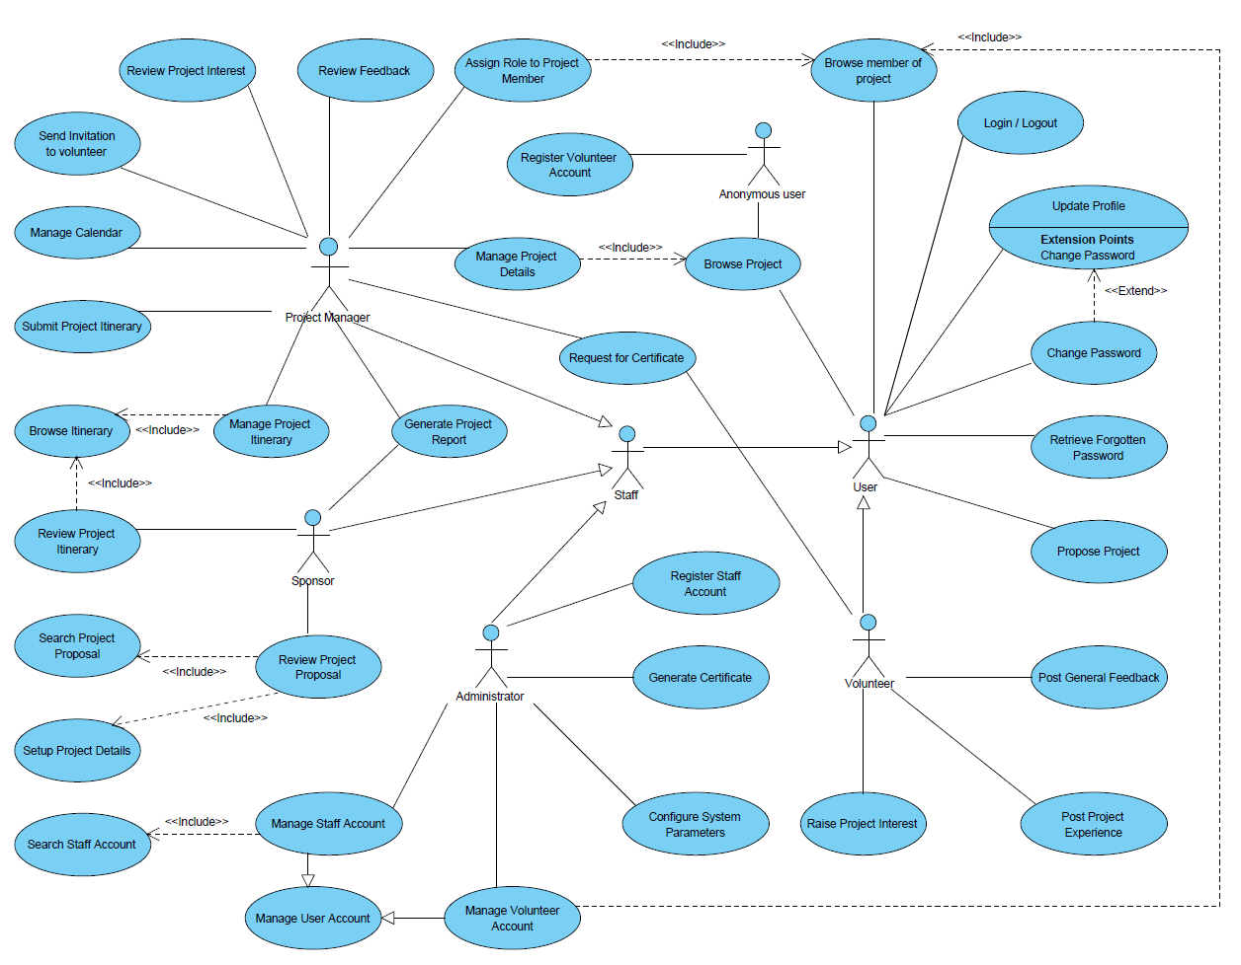

ANNEX D Amendment History

This is a record of all amendments made to the Document.
Version | Chapter / Section | Page No | Notes of Amendments or Changes

